**Sapporo Snow**

The Sapporo Snow Festival (さっぽろ雪まつり, Sapporo Yuki Matsuri) is held during one week every February in [Hokkaido](https://www.japan-guide.com/list/e1101.html)'s capital [Sapporo](https://www.japan-guide.com/e/e2163.html). It is one of Japan's most popular winter events.

The Sapporo Snow Festival was started in 1950, when high school students built a few snow statues in [Odori Park](https://www.japan-guide.com/e/e5301.html). It has since developed into a large, commercialized event, featuring spectacular snow and ice sculptures and attracting huge numbers of visitors. The festival is staged on three sites: the Odori Site, Susukino Site and Tsu Dome Site.

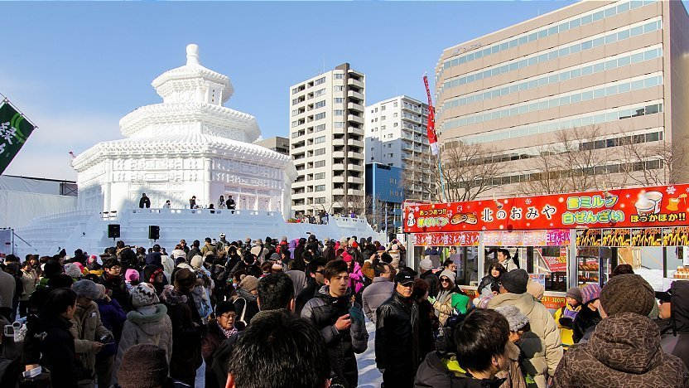

Odori Site

The main site is the **Odori Site** in Sapporo's centrally located 1.5 kilometer long [Odori Park](https://www.japan-guide.com/e/e5301.html). The festival's famous large snow sculptures, some measuring more than 25 meters wide and 15 meters high, are exhibited there. They are lit up daily until 22:00. Besides about a dozen large snow sculptures, the Odori Site exhibits more than one hundred smaller snow statues and hosts several concerts and events, many of which use the sculptures as their stage.

A good view over the Odori Site can be enjoyed from the Sapporo TV Tower at the site's eastern end. The tower has extended hours (8:30 to 22:30) during the festival. Admission to the top observatory costs 1000 yen. A 1500 yen ticket allows for a day visit and a night visit.

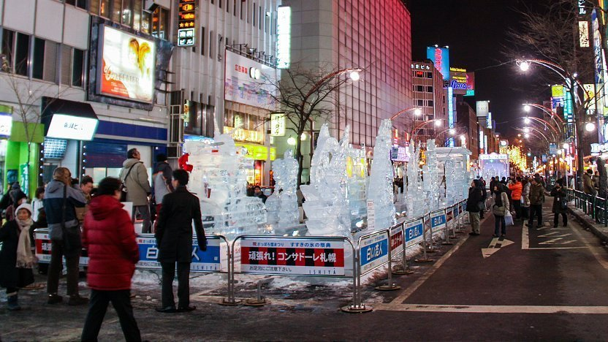

Susukino Site

The **Susukino Site**, located in and named after Sapporo's largest entertainment district, exhibits about one hundred ice sculptures. [Susukino](https://www.japan-guide.com/e/e5305.html) is located only one subway stop south of Odori Park. The ice sculptures are lit up daily until 23:00 (until 22:00 on the festival's final day).

The less centrally located **Tsu Dome Site** is a family oriented site with three types of snow slides, snow rafting and more snow sculptures. Inside the dome, there are many food stands and a stage for events. The Tsu Dome Site is open daily from 9:00 to 17:00 (hours for the 2024 festival have not been announced yet).



Tsu Dome Site

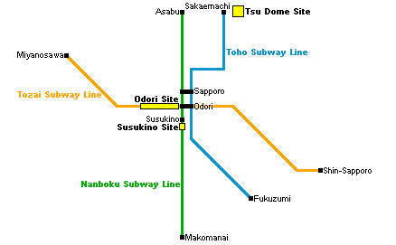

While the Odori and Susukino Sites are in central Sapporo, the Tsu Dome Site is located outside the city center. Access is possible by shuttle bus (2024 details to be announced) or in a 15 minute walk from Sakaemachi Station, the terminal station of the Toho Subway Line (10 minutes, 250 yen from Sapporo Station). Parking is not available near the Tsu Dome Site.